📘 Carbon Fiber Recycling & Crushing System Solution
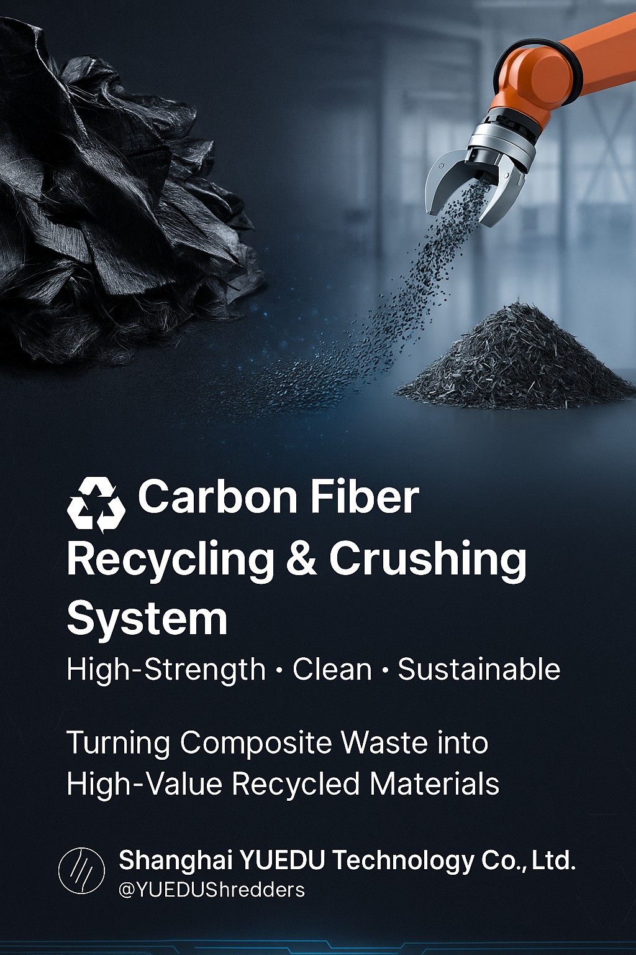
Client Industries:
Carbon composite plants, wind turbine blade manufacturers, automotive component makers, UAV producers, and modified plastics factories.

1. Industry Background
Carbon fiber composites are widely used in aerospace, automotive, wind energy, and high-end manufacturing for their light weight and high strength.
However, recycling scrap prepregs and end-of-life components is challenging. Conventional shredders cause conductive dust, excessive fiber breakage, and tool wear.
After being shredded to ≤2 cm, recycled carbon fibers (rCF) retain around 90% of their strength and electrical conductivity, enabling reuse across multiple sectors with over 60% cost savings compared to virgin fibers.
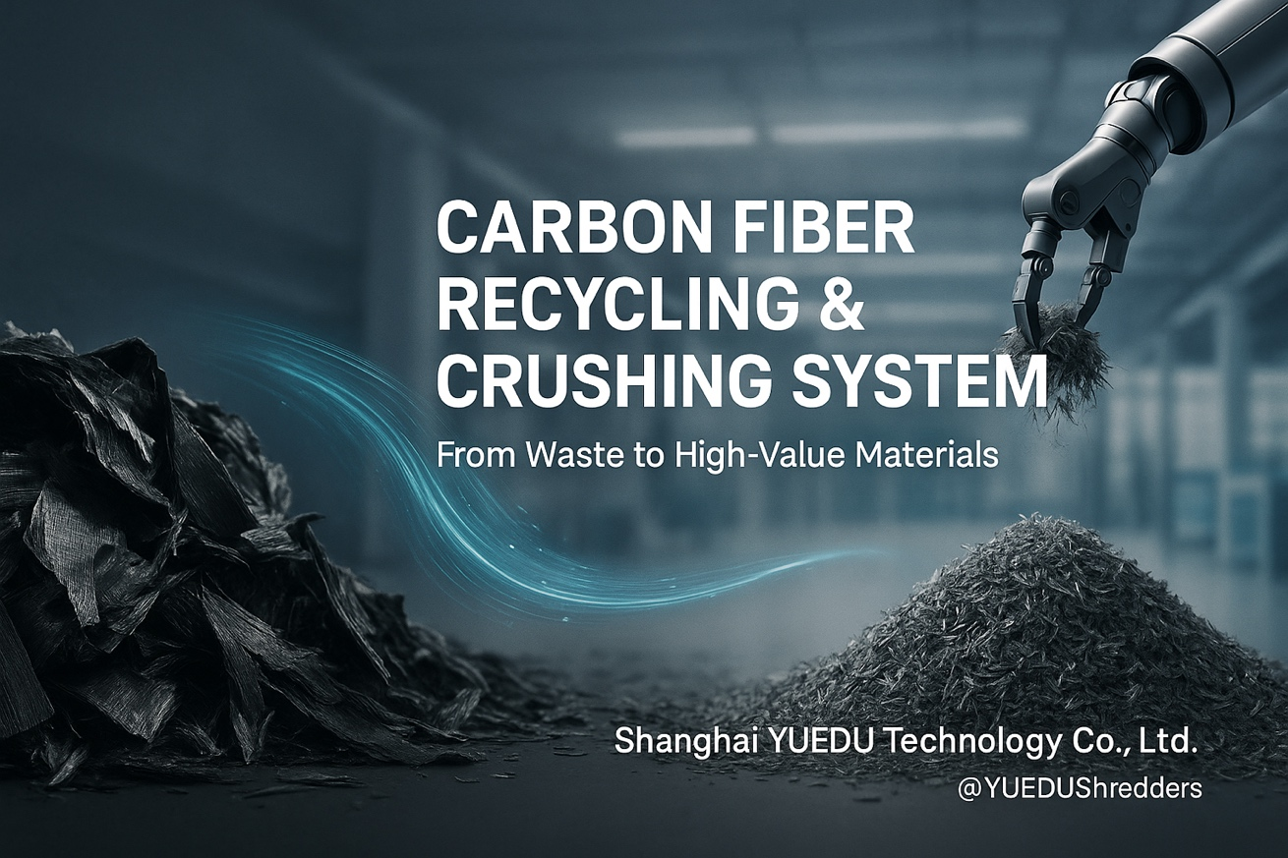

2. Customer Pain Points
No. | Pain Point | Description
1 | Conductive dust risk | Fine carbon dust may cause short circuits or contamination.
2 | Difficult to shred | High toughness damages blades or causes jamming.
3 | Poor size control | Hard to maintain stable 10–20 mm output.
4 | Heat buildup | High temperature leads to oxidation and brittleness.
5 | Environmental limits | Open systems fail to meet EHS dust standards.

3. YUEDU Solution
System Name: YD-FSJSL Series Carbon Fiber Crushing & Recovery System
System Flow: Pre-shredding → Fine crushing → Cooling → Dust collection → Screening → Bagging
Key Features:
- ⚙️ Dual-shaft pre-crusher + precision shredder for 10–20 mm control
- 🧲 Anti-static sealed housing and dust-proof enclosure
- 💎 High-chromium wear-resistant blades for long life
- ❄️ Temperature control < 25 °C to preserve fiber structure
- 🧹 Automatic screening for uniform particle size
- 🔧 Modular design for fast blade and filter replacement

4. Application Fields
Industry | Field | Typical Use
🚗 Automotive | Vehicle parts | Injection molded components, conductive PA66 compounds
🛩 Aerospace / Drone | Aviation | Structural reinforcement, inner shell filling
⚙ Engineering Plastics | Modification | Carbon-reinforced PPS/PEEK/PC materials
🏗 Construction | Civil | Concrete reinforcement, crack-resistant flooring
🔋 New Energy | Wind & Hydrogen | Blade and tank outer layer reinforcement

5. Results & Benefits
✅ Strength retention ≥ 90%
✅ Material cost reduction ≥ 60%
✅ Partial replacement of virgin carbon fiber
✅ Dust capture efficiency ≥ 99% (EHS compliant)
✅ Optional smart feeding & monitoring system

6. Supported Models
Model | Application | Feature
YD-SSJ Twin-Shaft Shredder | Primary shredding | Ideal for composite sheets & prepregs
YD-FSJ Heavy-Duty Crusher | Secondary shredding | High-strength blades + cooling system
YD-SL600 Silent Cooler | Fine sizing | Low noise, fully enclosed structure

7. Optional Configurations
- Magnetic separator
- Explosion-proof dust collector
- Automatic weighing & packaging unit
- Smart monitoring platform

8. YUEDU Value
Through intelligent shredding and material recycling technology,
Shanghai YUEDU Technology Co., Ltd. helps clients shift from “waste disposal” to “resource regeneration,”
achieving energy saving, cost reduction, environmental protection, and circular manufacturing.
“From Waste to Wealth — Turning Composite Scrap into New Materials.”

9. Typical Case
Client: LN New Energy Co., Ltd.
Application: Wind turbine composite recycling line
Configuration: YD-SSJ + YD-FSJ + dust & screening unit
Result: Capacity 500 kg/h, dust leakage < 1%, 72-hour stable continuous operation.

🌐 Contact Us
Shanghai YUEDU Technology Co., Ltd.
📞 Contact Us to explore more customized models and tailored shredding solutions that suit your specific needs!
Let us help you find the perfect equipment for your application.
📱 Sales Supervisor: +86 159 0178 2779 (WhatsApp / WeChat / Facebook)
📱 Administrative Supervisor: +86 137 6138 5116
📧 Email: yuedushredders@gmail.com | denghao8410@gmail.com
🌐 Website: www.yuedushredders.com
@YUEDUShredders – Empowering Global Industries with Intelligent Destruction Systems.

